Side & Rear Track Installation:
- Center the long side rails between the top metal supports. (The C channels face out)
- Using the supplied bolts, washers and nuts, install the rails in the existing top mounting holes.
- Place the spacers between the C-channel and the top mounting area and install the bolts. (Photo A)
- Install the self - tapping screws at the rear of the C channels.
- Tighten all hardware.
- Locate the small rail and place the track flush on the inside of the rear strut.
- Pop rivet the track to the strut using the provided rivets.
Sleeve & Enclosure Installation:
- Remove the windshield from the golf car.
- Remove the “sleeves” from the enclosure.
- Wrap the sleeve around the frame so that the cutout for the windshield clip is in the proper position.
- Engage the small zipper so it wraps snugly around the frame. The zipper should be positioned on the back of the windshield frame. (Photo B)
- Install rear and side enclosure panels by sliding them into the bottom C-Channels.
- Zip Enclosure to Sleeve.
- Select the desired valance and slide in to the top C-Channel.
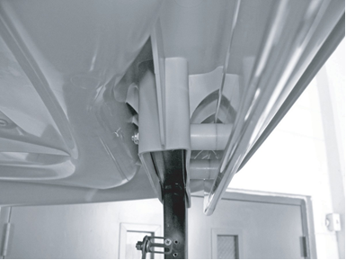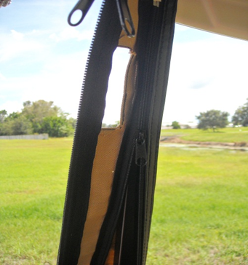
Photo A Photo B

